**Idea/Approach Details**

**Ministry Category:** Department of Defence Production, Ministry of Defence

**Problem Statement:** To detect anomaly in current ship trajectory based on historical data

**Team Leader Name**:  Vanessa Almond

**College**: Fr C Rodrigues Institute of Technology, Vashi

**Idea:**

The project provided a solution for detecting anomalies in current ship trajectory in maritime traffic based on clustering results of historical data. The proposed method decides for each trajectory point if the vessel is anomalous, considering features like longitude, latitude, speed and direction. We created clusters that can detect anomalous navigational behaviour based on the mentioned parameters. Anomalies are all the GPS (Geographic Positioning System) points in a track that deviate from normal direction or speed, or are relatively distant from a cluster. The idea was to generate the commonly traversed routes using the historical AIS data and spatial clustering(modified DBSCAN) algorithm. For each track the algorithm will return an anomaly ratio. If the anomaly ratio exceeds the threshold values the system will notify the authorities concerned.

**Solution Prototype:**

The solution can be classified into 3 models

1.  Traffic Patterns Extraction Model

The proposed clustering-based normal traffic patterns extraction model first divides the data into moving and stopping parts respectively based on a stopping SOG (Speed Over Ground) threshold of 0.5 knots. For the case where SOG is not less than 0.5 knots, we propose DBSCANSD as the basic algorithm to detect the main traffic lanes within the data. The algorithm’s output is a set of Gravity Vectors (GV), which are vectors formed by 5 features: average COG, average SOG, average Latitude, average Longitude and Median Distance. The Median Distance of a GV is the median of all the distances between the points in the cell and the cell’s average geographical point. For the case where the SOG is less than 0.5 knots (stop areas), the original DBSCAN algorithm is executed because speed and direction are not important factors.

2. Anomaly Detection Model

After the pattern extraction, the number of abnormal points are identified in comparison to the median distance. The anomaly ratio ie no of abnormal points / Total no of points is computed. If the ratio exceeds the defined threshold value then an anomaly is detected.

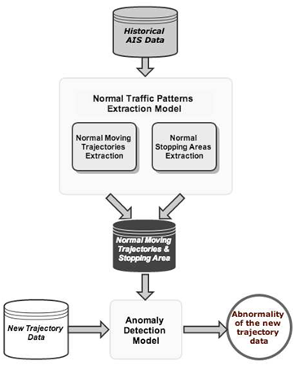

**Technology Stack:**

1. Web Technology: HTML, CSS, PHP, AJAX, Javascript, Bootstrap, JQuery,.
2. Backend: Python, My SQL Database

Team Members

|  |  |  |  |  |
| --- | --- | --- | --- | --- |
| Vanessa Almond | 101460 | COMP VII | Female | vanessa.almond28@gmail.com |
| Sachin George | 101418 | COMP VII | Male | george.sachin96@gmail.com |
| Aditya Jadhav | 101419 | COMP VII | Male | adi9773435959@gmail.com |
| Tanvi Rajadhyaksha | 101444 | COMP VII | Female | rajadhyakshatanvi@gmail.com |
| Advaith Kamath | 101421 | COMP VII | Male | advaith14@gmail.com |
| Swapnil Shinde | 101454 | COMP VII | Male | swapnil96@gmail.com |